AgriIntelligence: A Complete Platform for Crop, Weather and Market Analytics with Machine Learning-Based Yield Prediction
D Kamal  Student  Department of Computer Science and Engineering,  Koneru Lakshmaiah Education Foundation,  Bowrampet,  Hyderabad, India  2420030290@klh.edu.in | V Chandra  Student  Department of Computer Science and Engineering,  Koneru Lakshmaiah Education Foundation,  Bowrampet,  Hyderabad, India  2420030291@klh.edu.in | G Khethana  Student  Department of Computer Science and Engineering,  Koneru Lakshmaiah Education Foundation,  Bowrampet,  Hyderabad, India  2420030461@klh.edu.in
Ms. Bonagani Prathusha
Assistant Professor (Project Guide)
Department of Computer Science and Engineering,
Koneru Lakshmaiah Education Foundation,
Bowrampet,
Hyderabad, India.

Abstract—Information that matters to farmers and agricultural planners such as crop performance, weather conditions and market prices is usually stored in datasets that are rarely examined together. AgriIntelligence is a Python-based platform created to bring these data into one place. AgriIntelligence combines a crop-yield dataset of 28,242 records from 101 countries, ten crops and years 1990–2013 with a snapshot of 2,733 market price records from 268 markets. AgriIntelligence. Explores both datasets and shows the results in a Streamlit dashboard containing five sections. For yield prediction AgriIntelligence trained a Linear Regression baseline and a Random Forest regressor using country, crop, year, rainfall, pesticide use and temperature. On a random 80/20 split Random Forest achieved an R² of 0.9876 (MAE 3,467 hg/ha RMSE 9,468 hg/ha) compared with 0.6448 for the Linear Regression baseline. Because a random split may overstate model performance AgriIntelligence also tested Random Forest on years and on countries that were unseen. On those tests Random Forest R² fell to 0.9546 and 0.6022. Thus Random Forest is dependable for known countries. Not yet for new regions. The market module of AgriIntelligence compares commodity prices across markets. The available data covers a single day so the market module supports comparison rather than forecasting. AgriIntelligence discusses these limits. Outlines the next steps.
Keywords—Crop yield prediction, Random Forest, agricultural analytics, market price analysis, exploratory data analysis, data preprocessing, Streamlit dashboard, data science.

I. INTRODUCTION
Farmers and planners need three kinds of information that are rarely found together: crop performance, weather and input conditions and current market prices. In practice each kind comes from a source. Yield statistics are released by agencies. Climate data comes from bodies. Daily prices are posted by market boards. Anyone who wants to ask a question—such as whether wetter countries have potato yields or how much tomato prices differ between towns—must download several files and combine them manually.
Calculating yield by hand is slow. A static report does not allow the reader to ask a follow-up question. Machine learning has been used for yield prediction for years. Much of that work appears as stand-alone models. There is usually no user interface that a non-programmer can open and the models rarely appear next to market information.
This paper describes AgriIntelligence, a project created for our Data Science course (24AD3107) to bridge that gap on a scale. AgriIntelligence takes a crop-yield dataset and an agricultural market price dataset cleans them performs analysis and visualisation trains a Random Forest model to predict yield and presents everything through a Streamlit dashboard. AgriIntelligence is careful about what the numbers represent. In particular AgriIntelligence checked the headline accuracy using validation than a simple random split (see Section V-D).
The objectives are: (1) to collect and clean crop, weather-related and market data in one workflow; (2) to study how rainfall, temperature and pesticide use relate to yield; (3) to build and evaluate a model that predicts crop yield; (4) to compare commodity prices across markets; and (5) to present the results, in a dashboard. The rest of the paper is organized as follows. Section II reviews related work. Section III describes the data. Section IV presents the framework. Section V discusses the results. Section VI concludes.

II. LITERATURE SURVEY
Van Klompenburg et al. Studied the machine learning literature on crop yield prediction. They found that temperature, rainfall and soil type are the features used often. Neural-network methods were the common technique [1]. They believe that using diverse datasets and improving models will make predictions better. Elavarasan et al. Looked at the factors that feed the models like weather, soil and crop management. They discovered that merging factors usually leads to better yield forecasts [2]. They also highlight factors that future research could include.
At the level Thimmegowda et al. Compared multiple linear regression and an artificial neural network for rice yield in eleven districts of Karnataka. They trained the models on data from 1980 to 2019. Tested them on 2019–2020 [3]. Their results show that weather variables alone hold information about yield even though the study focuses on a single crop in one state. On the market side Hegde et al. Predicted commodity prices using ARIMA, SARIMA and recurrent networks. They also added a Kannada voice bot so that farmers could hear the forecasts in their language [4].
For the learning algorithm Random Forest [5] works with tabular data. It handles non-linear relationships and interactions between inputs without needing tuning. Jeong et al. Discovered that Random Forest is more accurate than regression for predicting wheat, maize and potato yields on both global and regional scales [6]. This supports using Random Forest with a linear model as a baseline. Table I summarises the gaps we found in the literature. Shows how this project addresses them.

TABLE I
Existing Practice and the Project’s Response
Existing practice | Limitation | AgriIntelligence
Crop, weather and market data analysed | Hard to relate one to another | One workflow; weather enters as rainfall and temperature columns
Manual yield estimation | Slow not data-driven | Random Forest regression on six inputs
Raw datasets | Hard to interpret | Cleaning, summaries and charts
Static reports | No interaction | Interactive Streamlit dashboard
Single-purpose tools | Several tools needed | Crop, factor and market views in one app

III. DATA RESOURCES

Two datasets are used. Both are saved as CSV files in the project’s data folder. The cleaned versions are kept next to the files.
A. Crop Yield Dataset
The crop dataset contains 28,242 records. It covers 101 countries and ten crops. Cassava, maize, plantains and others, potatoes, rice (paddy) sorghum, soybeans, sweet potatoes, wheat and yams. For the years 1990 to 2013. The dataset follows a well-known compilation that combines FAO production data and pesticide figures with climate records for rainfall and temperature [12]. Each record lists the country, crop, year yield measured in hectograms per hectare (hg/ha) average annual rainfall in millimetres pesticide use in tonnes and average temperature in degrees Celsius. One hg/ha equals 0.1 kg/ha so the average yield of 77,000 hg/ha is 7.7 tonnes per hectare. Rainfall and pesticide values are identical for every crop reported by a country in a year; this detail is important for the validation process in Section V. Table II provides summary statistics.

TABLE II
Summary of the Crop Yield Dataset
Attribute | Mean | Std. Dev. | Min | Max
Yield (hg/ha) | 77,053 | 84,957 | 50 | 501,412
Rainfall (mm/yr) | 1,149 | 710 | 51 | 3,240
Pesticides (tonnes) | 37,077 | 59,958 | 0.04 | 367,778
Temperature (°C) | 20.54 | 6.31 | 1.30 | 30.65
Year | 2001.5 | 7.05 | 1990 | 2013

B. Agricultural Market Dataset
The market dataset contains price records from Indian agricultural markets also known as mandis and seems to come from the Government of India open data platform [13]. After cleaning it has 2,733 records for 145 commodities 268 markets, 157 districts and 16 states. Each record includes the state, district, market, commodity, variety, grade, arrival date and the minimum, maximum and modal price quoted in rupees per quintal. A key point is that every record has the arrival date: 19 May 2025. Because all data come from one day this dataset alone cannot show how prices change over time. Table III lists the characteristics.

TABLE III
Summary of the Market Dataset
Item | Value
Records | 2,733
Commodities / markets | 145 / 268
Districts / states | 157 / 16
Arrival date | 19 May 2025 (single day)
Modal price, median (INR/quintal) | 2,500
Modal price, mean (INR/quintal) | 3,528
Most frequent commodities | Tomato (155) onion (154) potato (154)

C. Cleaning and Preprocessing
We removed the index column that remained after exporting the crop data renamed the columns to shorter names such as Country, Crop, Year, Yield, Rainfall, Pesticides, Temperature and checked that there were no missing values and that the data types were appropriate.
We counted duplicates. Discovered 2,310 rows, which is 8.2% of the data that repeat in every field.
We kept these repeated rows in the dataset for the experiment because the original source contains repeated country–crop–year entries.
Section V-D shows what happens if these repeated rows are removed.
For the market data we renamed the price columns converted the day- dates into a proper date type forced the price columns to numeric and removed any row that had a missing commodity, market, date or modal price.
All 2,733 rows passed these checks so none were removed.

IV. PROPOSED FRAMEWORK: AGRIINTELLIGENCE
AgriIntelligence follows the data science steps of collecting, cleaning, preparing, exploring, building models and displaying results. Figure 1 shows how these parts fit together. We built the system in Python using Pandas and NumPy for data handling, Matplotlib and Seaborn for creating graphs Scikit-learn for building models Joblib for saving the trained model and Streamlit for the user interface. Development was carried out in VS Code and Jupyter Notebook.
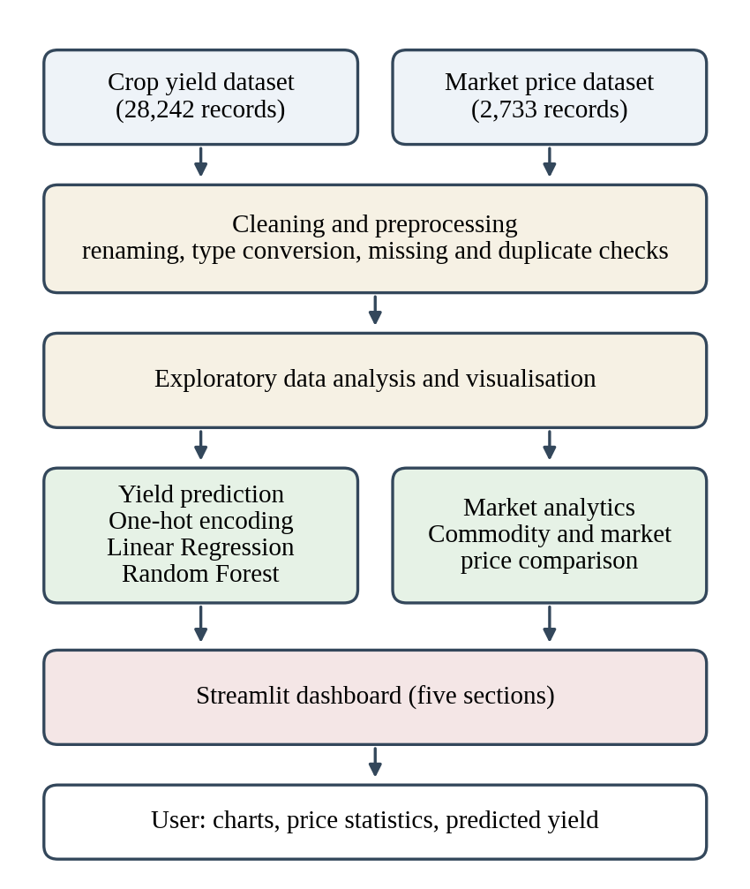
Fig. 1. Workflow of AgriIntelligence.

A. Exploratory Analysis
Before building any models we examined how the data is distributed across crops and countries. We compared yield by crop and by country. We also plotted yield against rainfall, temperature and pesticide use. We used a correlation matrix for the columns Year, Yield, Rainfall, Pesticides and Temperature to look for relationships. The dashboard repeats these views using binned ranges for rainfall, temperature and pesticide use to yield.

B. Yield Prediction Model
The yield prediction model takes six inputs: country, crop, year, rainfall, pesticide use and temperature. We one-hot encode the inputs, country and crop and ignore any unseen categories when predicting. The four numeric inputs are used unchanged. We wrap the encoding and the model in a pipeline so that the same transformation is applied during training and during prediction. We split the data 80/20 at random using the fixed seed random_state = 42 which produces 22,593 training records and 5,649 test records.
We trained two models. We started with Linear Regression. The second model was a Random Forest regressor using 100 trees and the default settings. We did not tune any hyperparameters. We saved the trained Random Forest pipeline with Joblib. Loaded it in the dashboard. We evaluate performance with the absolute error the root mean squared error and the coefficient of determination:
MAE = (1/n) ∑ |y_{i} − ŷ_{i}| (1)
RMSE = √[ (1/n) ∑ (y_{i} − ŷ_{i})² ] (2)
R² = 1 − ∑ (y_{i} − ŷ_{i})² / ∑ (y_{i} − ȳ)² (3)
where y_{i} is the actual yield, ŷ_{i} the predicted yield, ȳ the average actual yield and n the number of test records. Errors are in hg/ha.

C. Market Analytics Module
The market module provides statistics. For a chosen commodity it shows the average price, the price and the highest price ranks the ten markets with the highest average price and lists the data. Across the dataset it ranks commodities and markets by average price. and lists the data. Across the dataset it ranks commodities and markets by average price.

D. Interactive Dashboard
The dashboard is built with Streamlit. Has a sidebar that lets the user select one of five sections. Crop Analytics displays yield by crop and the ten countries with the average yield. Weather Analytics links binned rainfall and temperature ranges to yield. Agricultural Factors does the same for pesticide use. Shows a correlation heatmap. Market Analytics displays the price view for a commodity. Crop Yield Prediction allows the user to choose a country and a crop enter a year rainfall, pesticide use and temperature and press a button to obtain the predicted yield from the saved model.

V. RESULTS AND DISCUSSION

A. Patterns, in the Crop Data
I find that crop type separates the records more than any factor. Figure 2 shows that root and tuber crops have higher yields than cereal crops and soybeans. Potatoes average 199,800 hg/ha and cassava about 150,500 hg/ha while maize averages 36,300, wheat 30,100 and soybeans 16,700. At the country level the United Kingdom with 241,000 hg/ha Belgium with 216,500 and Denmark with 214,000 lead the list. However part of this difference reflects the crops each country reports than pure farming performance.
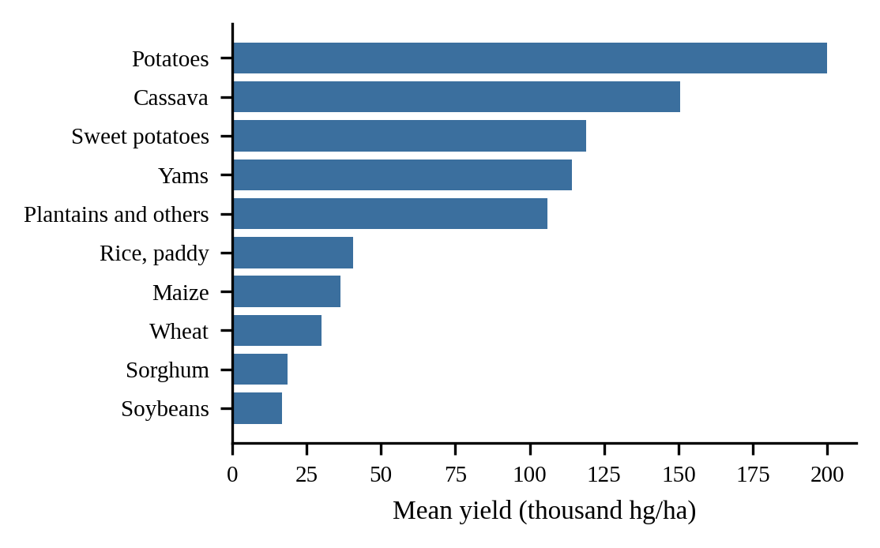
Fig. 2. Mean yield by crop.
Figure 3 displays the correlation matrix. Yield shows linear relationships with other factors: 0.09 with year 0.00 with rainfall 0.06 with pesticide use and –0.11 with temperature. Rainfall and temperature are moderately correlated with each other coefficient 0.31. These weak numbers do not mean that weather is unimportant. They simply show that yield changes a lot between crops, which masks any effect of rainfall or temperature when all crops are combined.
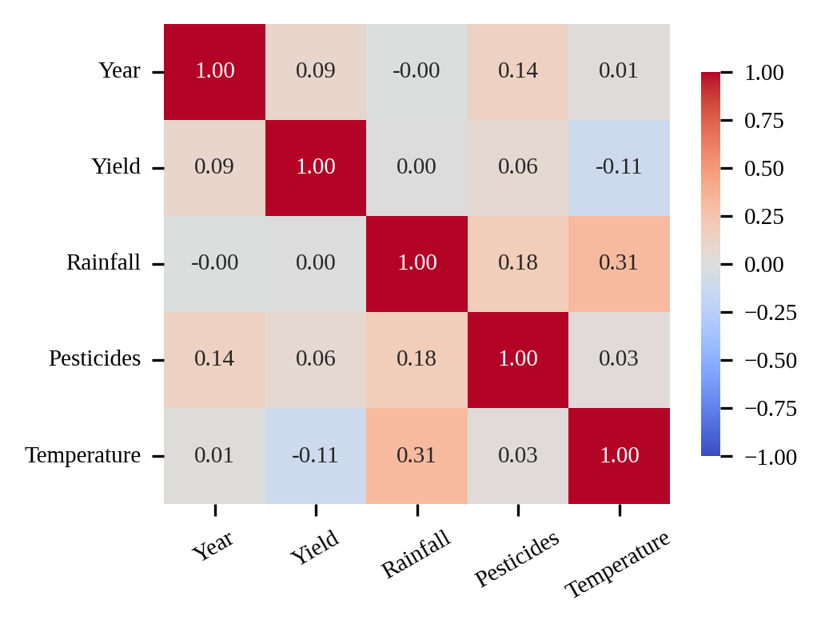
Fig. 3. Correlation between the variables.

B. Model Performance
Table IV compares the two models on 5,649 test records. The Random Forest model explains 98.8 % of the variation in yield with an absolute error of 3,467 hg/ha and a root-mean-square error of 9,468 hg/ha (mean-square error 89,633,724). The linear baseline achieves an \(R^{2}\) of 0.6448 and its errors are nine times larger. This gap indicates that the relationship between inputs and yield is non-linear mainly due to interactions between crop and country. Figure 4 displays predicted yield versus yield for the Random Forest; most points lie close to the diagonal while some errors appear at the high-yield end.

TABLE IV
Test-Set Performance (Random 80/20 Split)
Model | MAE | RMSE | R²
Linear Regression | 31,792 | 50,758 | 0.6448
Random Forest | 3,467 | 9,468 | 0.9876

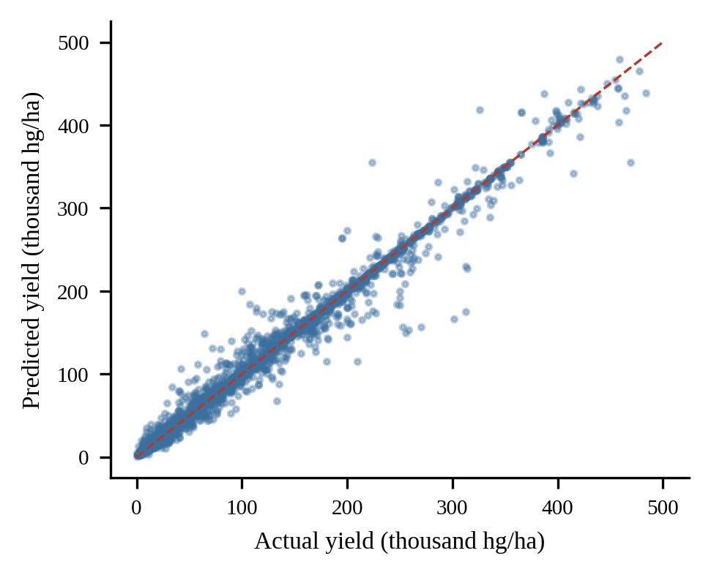
Fig. 4. Predicted versus yield for the Random Forest on the test set (dashed line: perfect prediction).

C. Which Inputs the Model Relies On
I used permutation importance on the test set to determine which inputs the Random Forest depends on. This is measured as the drop in \(R^{2}\) when one column is shuffled (see Figure 5). Crop is the important input, with a drop of about 1.6 followed by country (0.28) pesticide use (0.18) temperature (0.12) rainfall (0.10) and year (0.06). This ranking tells us what the model uses; it does not prove that pesticides cause yield. Because pesticide figures represent totals they probably also stand in for country size and farming intensity.
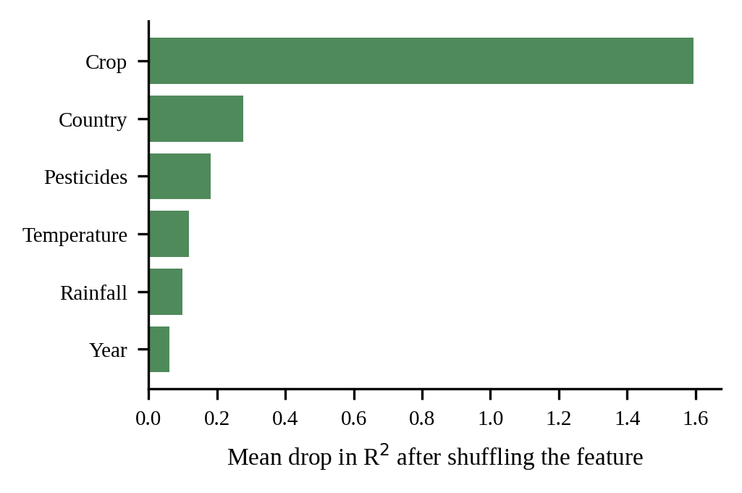
Fig. 5. Permutation importance of the model inputs.

D. Checking the Result Under Stricter Validation
A random split tends to place records from the country and crop often from nearby years into both the training and test sets. When duplicate rows are present. When rainfall and pesticide values repeat across crops in a country-year the model can appear better than it truly is. Therefore I repeated the experiment in three ways: (B) removing the 2,310 duplicate rows before performing a split; (C) training on data from 1990–2008 and testing, on 2009–2013, which simulates predicting future years; and (D) holding out 20 % of the countries entirely which simulates predicting for a new region. Each setting was run once with a fixed seed. Table V reports the results.

TABLE V
Random Forest and Linear Regression Under Different Validation Settings
Setting | Model | MAE | RMSE | R²
Random split (Table IV) | RF | 3,467 | 9,468 | 0.9876
B. Duplicates removed, random split | RF | 4,040 | 10,669 | 0.9843
C. Train ≤2008, test 2009–13 | LR | 36,249 | 55,252 | 0.6603
C. Train ≤2008, test 2009–13 | RF | 10,429 | 20,198 | 0.9546
D. Unseen countries | LR | 36,633 | 59,793 | 0.6495
D. Unseen countries | RF | 35,105 | 63,702 | 0.6022

Removing duplicates hardly changes the results (R² 0.9843) so duplicates were not the reason for the performance. Predicting later years is harder as the error more than doubles. R² stays at 0.9546, which is still a strong result for known countries. Predicting for countries not in the training data is different. The Random Forest drops to an R² of 0.6022. Ends up slightly behind the linear baseline (0.6495). In words much of the model’s accuracy comes from having seen the country before and the 0.9876 figure should be read as accuracy for countries in the dataset not as a general claim about new regions. We see this as the limitation of the current model.

E. Market Price Findings
Tomato, onion and potato are the most common commodities. Their prices differ a lot between markets on the day: tomato ranged from ₹400 to ₹9,950 per quintal across 145 markets (average ₹1,447) onion ranged from ₹600 to ₹6,000 across 135 markets (average ₹1,711) and potato ranged from ₹375 to ₹5,000 across 144 markets (average ₹1,506). Fig. 6 Shows the expensive commodities. The ranking was limited to 38 commodities that had least 20 records because 29 commodities appear only once and one record would otherwise dominate the average; black pepper for example is at the top of the unfiltered list based on only four records.

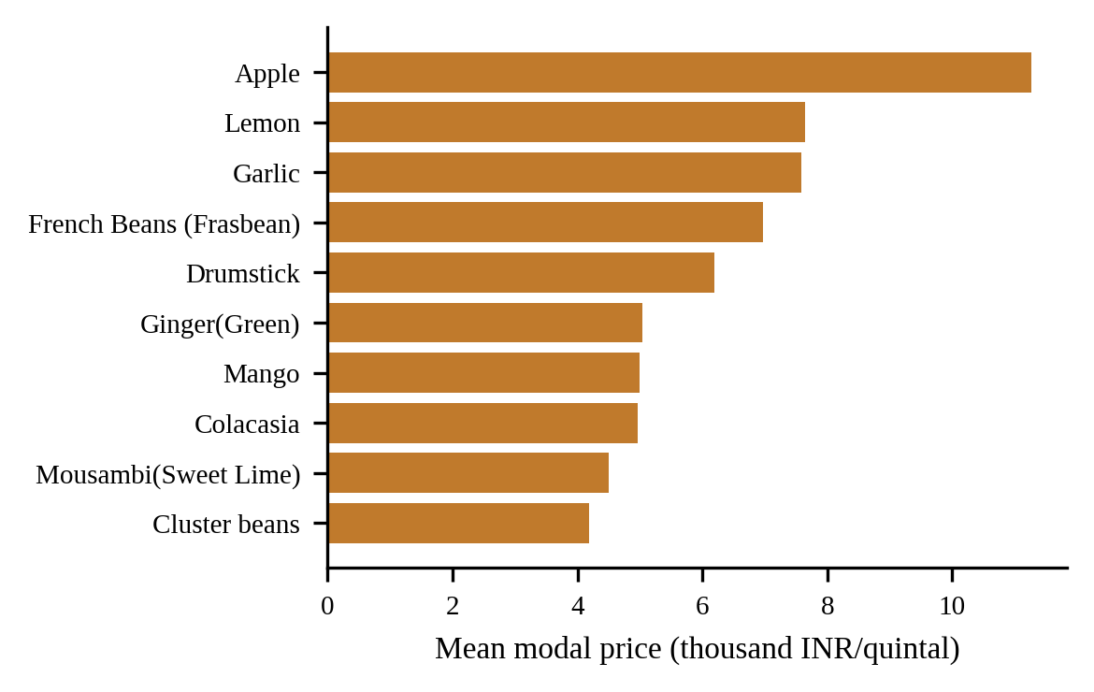
Fig. 6. Commodities with the highest mean modal price (at least 20 records each).
Because the data contains one date the price trend chart in the dashboard cannot show a real trend and the module should be seen as a tool for comparing markets and commodities on a single day. Seasonal. Price forecasting require data collected over many dates.

F. Limitations
Four limitations should be considered. First the crop data ends in 2013 and rainfall and temperature are country-level averages so they cannot capture a spell during a growing season. Second the crop and market datasets are not connected by location or time: the crop data is global while the market data is Indian so the platform shows them side by side but does not model one from the other. Third the model does not work well for countries that were not in the training set as shown in Section V-D. Fourth only Linear Regression and Random Forest were. No tuning was performed.

VI. CONCLUSION AND FUTURE SCOPE
AgriIntelligence gathers data on crop yields, weather and market prices. Combines them into one simple process. It presents this information through a dashboard that anyone can use without needing coding skills. A Random Forest model predicts crop yield well with an R² score of 0.9876 on a random split and 0.9546 on later years. This is far better than a linear model. However the model does not perform well when predicting for countries that were not in the training set, where it achieves an R² score of 0.6022. The market part of the system clearly shows how prices can differ greatly between markets on the day. We believe that showing the validation results together with the main number makes the project more useful because it shows where the model can be trusted.
More improvements could help with the problems mentioned. Collecting market prices for months would allow real trend analysis, season breakdowns and price predictions. Adding crop yield data at the district level and local weather data in India would link the two datasets geographically. Other models such as boosting, support vector regression and k-nearest neighbours could be compared and tuned with cross-validation grouped by country. Methods like SHAP could explain the predictions. Finally the dashboard could be launched online. Tested with farmers or people who work with farmers to see which parts they actually use.
REFERENCES
[1] T. Van Klompenburg, A. Kassahun and C. Catal "Crop yield prediction using machine learning: A systematic literature review," Comput. Electron. Agric. vol. 177 Art. No. 105709, 2020.
[2] D. Elavarasan, D. R. Vincent, V. Sharma A. Y. Zomaya and K. Srinivasan "Forecasting yield, by integrating factors and machine learning models: A survey," Comput. Electron. Agric. vol. 155, Pp. 257–282, 2018.
[3] M. N. Thimmegowda and others discuss weather-based statistical and neural network tools for forecasting rice yields in growing districts of Karnataka. This work appears in Agronomy, volume thirteen number three article number 704 2023.
[4] G. Hegde, V. R. Hulipalled and J. B. Simha present price prediction of agriculture commodities using machine learning and NLP. The paper was presented at the 2nd International Conference on Smart Technologies in Computing, Electrical and Electronics (ICSTCEE) 2021.
[5] L. Breiman writes about forests. The article appears in Machine Learning, volume forty-five, number one pages five to thirty-two, 2001.
[6] J. H. Jeong and colleagues explore forests for global and regional crop yield predictions. This study is published in PLoS ONE volume eleven number six article number e0156571, 2016.
[7] F. Pedregosa and others introduce scikit-learn, a machine learning library in Python. The paper is in Journal of Machine Learning Research, volume twelve pages 2825 to 2830, 2011.
[8] W. McKinney discusses data structures for computing in Python. The work was presented at the Python in Science Conference, 2010 pages fifty-six to sixty-one.
[9] C. R. Harris and colleagues explain array programming with NumPy. Their article appears in Nature volume five hundred eighty-five pages 357 to 362, 2020.
[10] J. D. Hunter writes about matplotlib, a 2D graphics environment. The paper is in Computational Science & Engineering volume nine number three pages ninety to ninety-five 2007.
[11] M. L. Waskom presents seaborn, a tool for data visualization. The article appears in Journal of Open Source Software volume six number sixty, article number 3021 2021.
[12] Food and Agriculture Organization of the United Nations offers FAOSTAT and the World Bank hosts the Climate Change Knowledge Portal. Both are available online at https://www.fao.org/faostat/
[13] Government of India provides the Open Government Data (OGD) Platform India. It can be accessed online at https://data.gov.in
[14] Streamlit offers streamlit documentation. The documentation is available online, at https://docs.streamlit.io

